SQL Analysis of E-Commerce Sales Data

Overview
This project focus was to extract meaningful business insights from an e-commerce sales dataset using Microsoft SQL server. SQL queries were used to retrieve, filter, aggregate, and summarize transactional data in order to identify sales trends, customer purchasing behavior, product performance, and operational patterns. Various SQL functions, were applied to answer key questions and to generate insights. This project was completed as part of the DecodeLabs Data Analytics Internship Program.

Objectives
The objectives of this project were to:
- To identify products contributing to high sales revenue
- To identify high-value customers based on revenue contribution
- To examine customer payment preferences
- To evaluate the distribution of order statuses
- To analyze revenue performance trends over time
- To generate business insights and recommendations from the analysis

Dataset Description
The dataset was provided by DecodeLabs and it contains transactional records such as:
- OrderID
- Date
- CustomerID
- Product
- Quantity
- UnitPrice
- ShippingAddress
- PaymentMethod
- OrderStatus
- TrackingNumber
- ItemsInCart
- CouponCode
- ReferralSource
- TotalPrice

Data Cleaning
Prior to analysis, the dataset was cleaned using Microsoft Excel, to ensure data consistency and accuracy. The data cleaning process included handling missing values, removing duplicates, and standardizing data formats.

Analysis
In Microsoft SQL Server, a database named ‘E-Commerce Sales Data’ was created and the cleaned dataset was imported into it. After which, SQL queries were run on the [dbo].['Cleaned Data$'] table and various SQL functions such as: SELECT, FROM, GROUP BY, ORDER BY, ROUND, DATENAME, COUNT(), SUM(), and AVG(), were used.

Queries were written to calculate the basic statistics such as;
Total Revenue: 1,264,761.96
Average Order Value: 1,053.97
Total Orders: 1,200
Interpretation: The dataset contains 1,200 customer orders that generated a total revenue of ₦1,264,761.96. The average order value was ₦1,053.97, which indicates that customers spent approximately ₦1,054 per transaction on average.

The analysis questions, queries, outputs and interpretations that were used to analyze this dataset are;
- Which products generate high sales revenue?

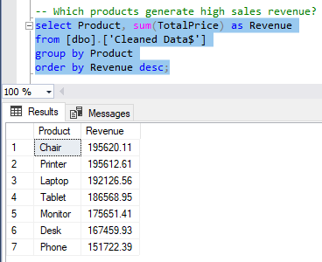
This analysis identified the products contributing to high sales revenue. Chair recorded the highest revenue at ₦195,620.11, followed by Printer at ₦195,612.61 and Laptop at ₦192,126.56. Phone generated the least revenue at ₦151,722.39.

- Who are the customers that generate high sales revenue?

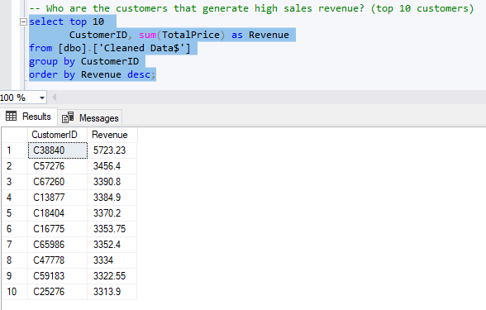

This analysis identified the top 10 customers that generate high sales revenue. These customers represent a significant portion of overall sales and may be considered high-value customers. Maintaining strong relationships with these customers can improve customer retention and long-term revenue growth.

- Which payment methods are most frequently used by customers?

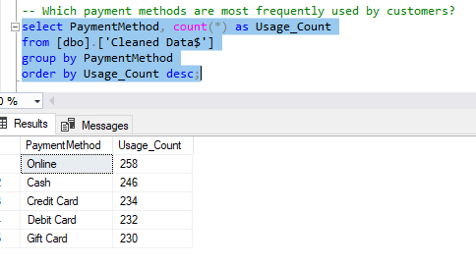

This analysis evaluated the payment method that are used by customers. Online payment was the most used method with 258 orders, followed by Cash with 246 and Credit Card with 234. Debit Card had 232 orders and Gift Card recorded the lowest with 230. The close distribution shows customers have varied payment preferences.

- What percentage of orders are cancelled, delivered, pending, returned or shipped?

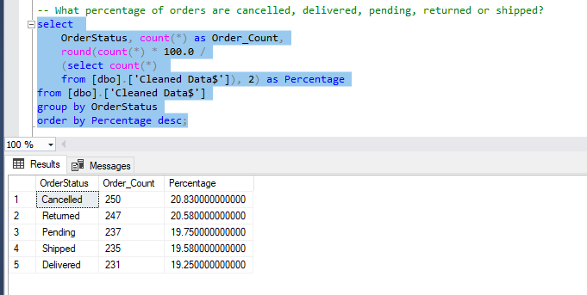

This analysis examined the percentage of orders that are cancelled, delivered, pending, returned or shipped. Cancelled orders were the highest at 250 (20.8%), followed by Returned at 247 (20.6%). Only 231 orders (19.2%) were successfully Delivered. The combined cancel and return rate of 41.4% is very high and is a key concern for the business.

- How has sales revenue changed over time?

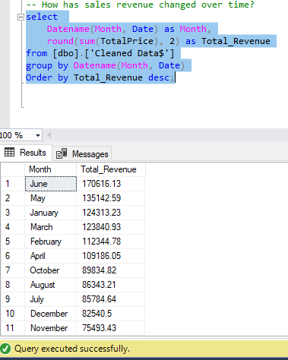

This analysis examined monthly revenue to see changes over time. June recorded the highest monthly revenue at ₦170,616.13, followed by May at ₦135,142.59 and January at ₦124,313.23. September had the lowest revenue at ₦69,321.65. Revenue was generally better in the first half of the year.

Key Insights
The SQL analysis revealed several important business insights which are:
- Among all products, chair emerged as the highest with a revenue of ₦195.6K, followed by other high revenue products such as printer and laptop. This makes them top performing products.
- Top 10 customers that contributed massively to sales were identified and this highlights the importance of customer retention strategies for high-value customers.
- It was discovered that, online payment was the most preferred payment method followed by cash, credit, debit and gift card.
- A total of 41.4% of all orders were either cancelled or returned, which is a significant loss for the business.
- Out of 1,200 orders, only 231 orders, were successfully delivered to customers.
- In the first half of the year, revenue improved as June was recorded the highest, with a significant amount of ₦170.6K before it declined from July – December.

Recommendations
Based on the insights of this analysis, the following recommendations are proposed:
- High Revenue Products such as Chair, Printer, and Laptop should be prioritized through increased marketing attention and inventory support, as they contribute well to the overall revenue. Proper investigation should also be conducted in response to low revenue products such as desk and phone.

- The identified top customers should be properly managed through personalized offers and customer engagement initiatives in order to encourage them for more purchases.

- Since Online Payment is the most frequently used payment method, the business should ensure that its online payment infrastructure remains secure, reliable, and user-friendly to maintain customer trust and convenience.

- The high rate of cancelled and returned orders should be examined to identify root causes which may be; delivery delays, product quality issues, inaccurate product descriptions, or customer service challenges.

- The increase in revenue that was observed between May and June should be further investigated to identify contributing factors that can be replicated during lower-performing periods.

Conclusion
This analysis has been able to extract insights within the e-commerce dataset, as it showed that revenue performance varies throughout the year, with significant growth observed from January – June. Chairs emerged as the highest revenue-generating product, while Online payment was the most preferred payment method among customers. The study also revealed the high rate of cancelled and returned orders, highlighting areas for operational improvement. Furthermore, the identification of high-value customers provides valuable information for customer retention and revenue optimization strategies.

